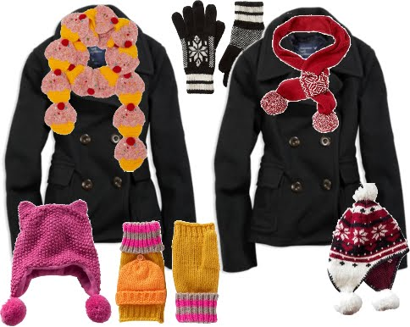

We are asking for any donations of coats, hats, gloves & scarfs please for us to donate to a local cause DN5 Street Project (they can be found on Facebook). If you have any items you could donate can you please bring them into college by Friday 13th December.

These are an amazing group of people who have also just helped the flood victims, here is some of their story…

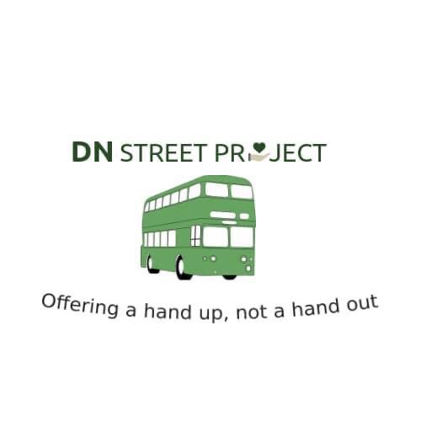Welcome to DN Street Project. We are an innovative and passionate not for profit organisation with charitable aims. The intention is to relieve and prevent poverty, focusing initially on homelessness and rehabilitation, followed by housing and employment.

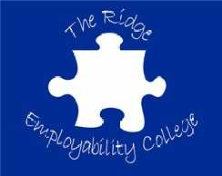

We are asking for any donations of coats, hats, gloves & scarfs please for us to donate to a local cause DN5 Street Project (they can be found on Facebook). If you have any items you could donate can you please bring them into college by Friday 13th December.

These are an amazing group of people who have also just helped the flood victims, here is some of their story…

Welcome to DN Street Project. We are an innovative and passionate not for profit organisation with charitable aims. The intention is to relieve and prevent poverty, focusing initially on homelessness and rehabilitation, followed by housing and employment.

