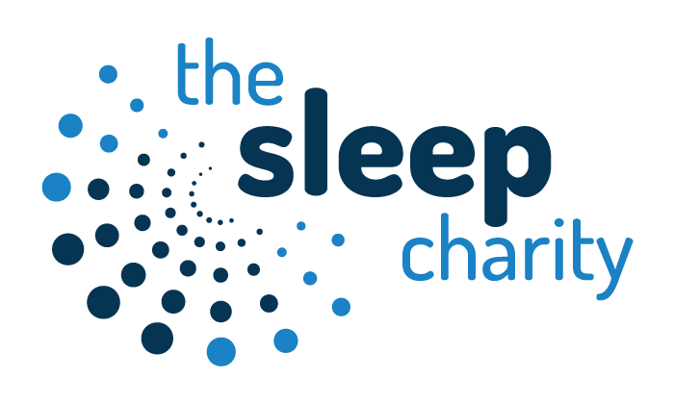

Are you the parent of a child with sleep issues?
Are you a professional who supports families with sleep problems?
Our online sleep foundation workshop
designed for both parents and practitioners in the Doncaster area
This course provides an introduction to our work and is the foundation for all of our other courses.
Materials are delivered entirely online through our e-learning portal. You will need to allow approximately one hour to complete the viewing of the materials plus additional time for exercises. A downloadable workbook is provided.

We offer the course to parents/carers in areas where we are able to provide further support through our Sleep Practitioners. Some families find that the information provided is enough to be able to make the necessary changes where others need more specialist support.
The course provides a good introduction to sleep for professionals supporting families.

The modules covered include:
- An introduction to The Sleep Charity
- The Importance of Sleep
- Sleep Physiology
- Causes of Sleep Issues
- Identifying Causes of Sleep Issues
- Good Sleep Practice

Learning Outcomes
At the end of this course you will be able to:
- Recognise the importance of sleep for wellbeing
- Identify possible reasons for children’s sleep issues
- Use some of the practical suggestions outlined

To find out more and to book your training please contact:
Claire on 07568 052300 or preferably email
claire@thesleepcharity.org.uk

www.thesleepcharity.org.uk

