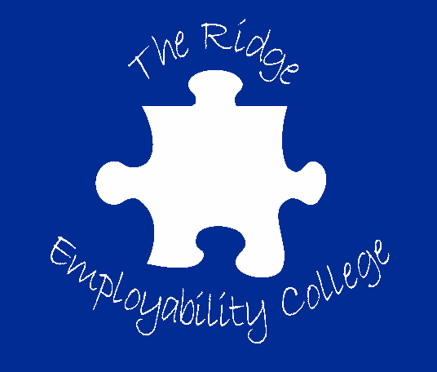

**Life After College**

**Coffee Morning**

**Friday 7th March 2025 10am – 11.30am**

This coffee morning is aimed at learners/parents/carers who are exploring provisions and support networks to help prepare for life after college.

Guests attending include: Representatives from Social Care, Department for Work & Pension, DICE, SMILE and Cambeth along with information from other providers.

**Scan the QR code below to book your place.**

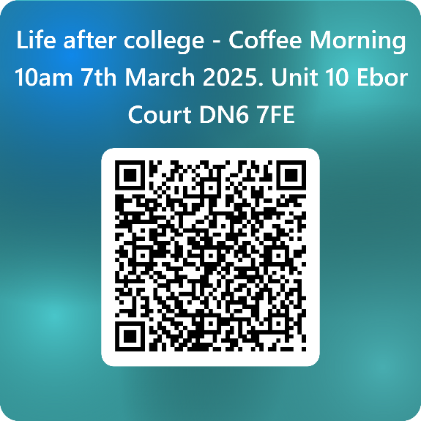

**Unit 10 (Reception) Ebor Court**

**Malton Way, Adwick-Le-Street**

**Doncaster DN6 7FE**